Starting work on blog website

Step 1 : Cleaning app.css and keep app.js simple

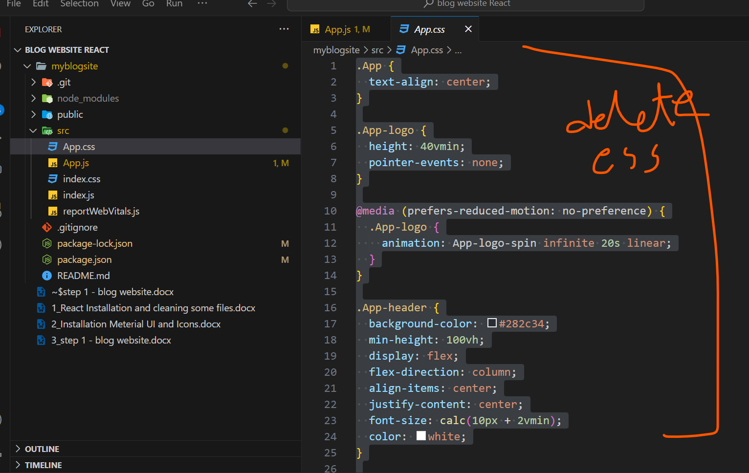

Clean App.js and keep it simple

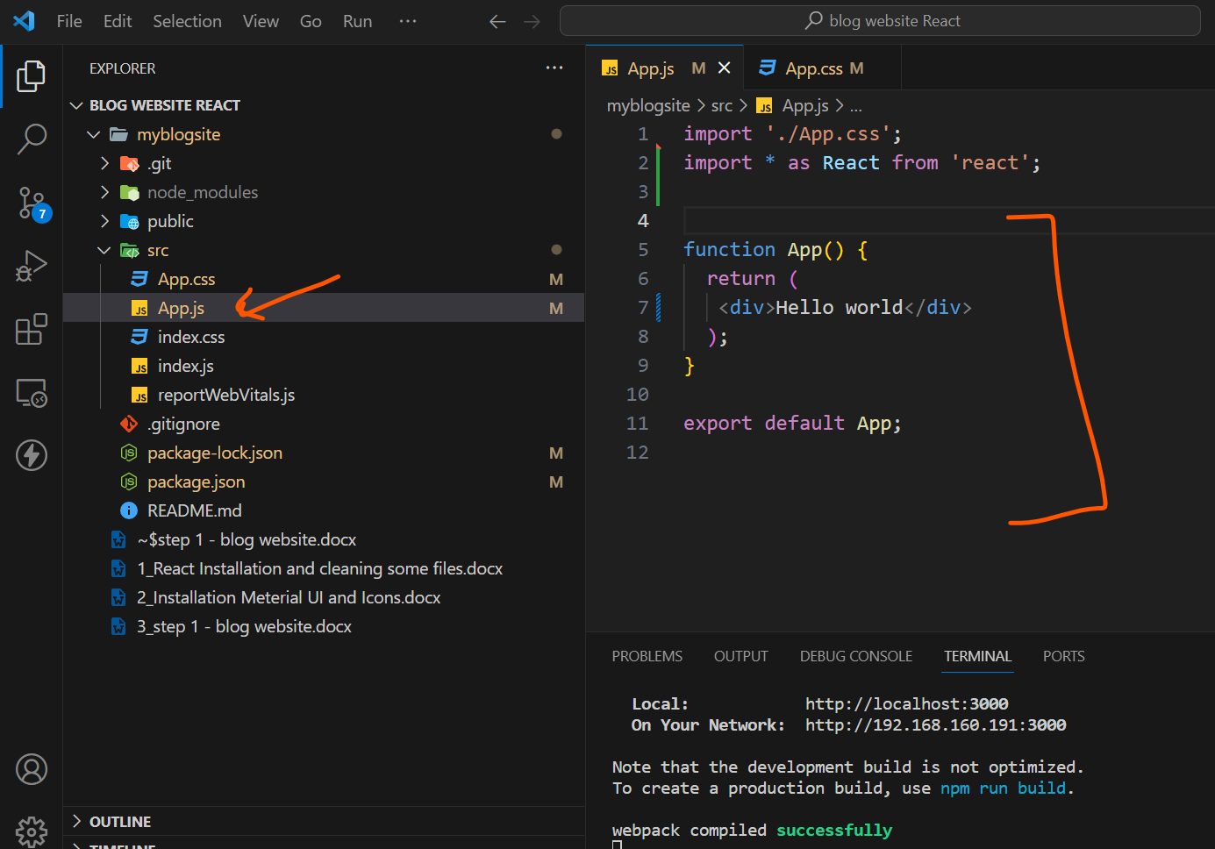

Check in the browser

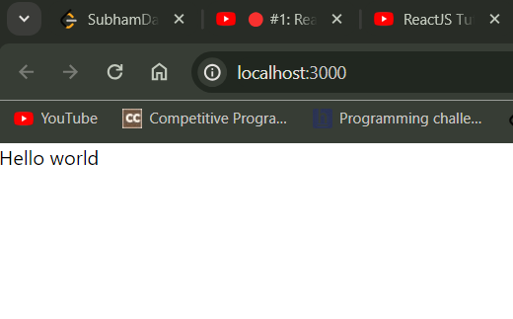

Step 2 : Create Container

To create a website always create container

The container centers your content horizontally. It's the most basic layout element.

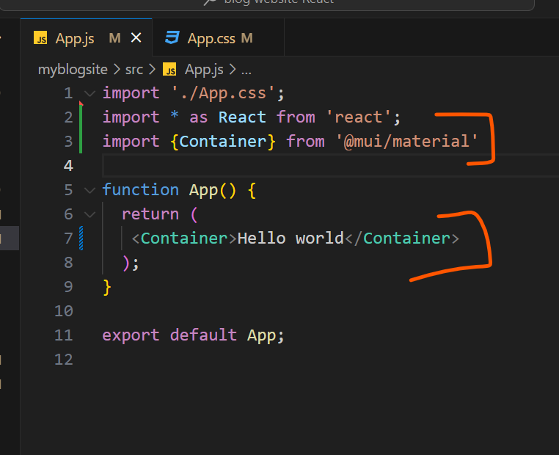

Inside this container we will put

Header

Body

Footer

Step -3 : break page into ‘header’ , ‘footer’ component

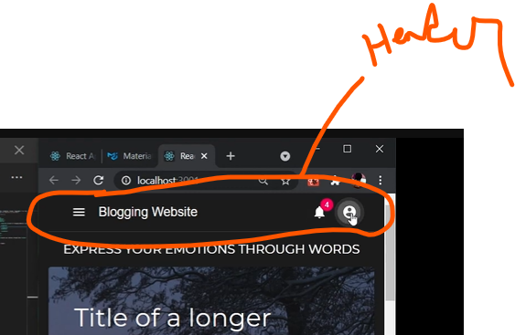

Create Header.js Component

And call it in App.js where it is placed inside <container>

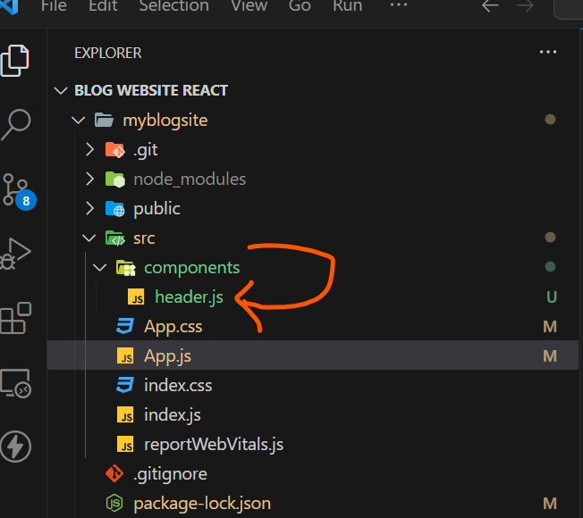

App.js

